Saddle Mountain:

Changes in Fuels & Photo Series

Sam Wozniak

SageSTEP

May 2018

Herbaceous and Shrub Fuels



Downed Woody Debris



Control

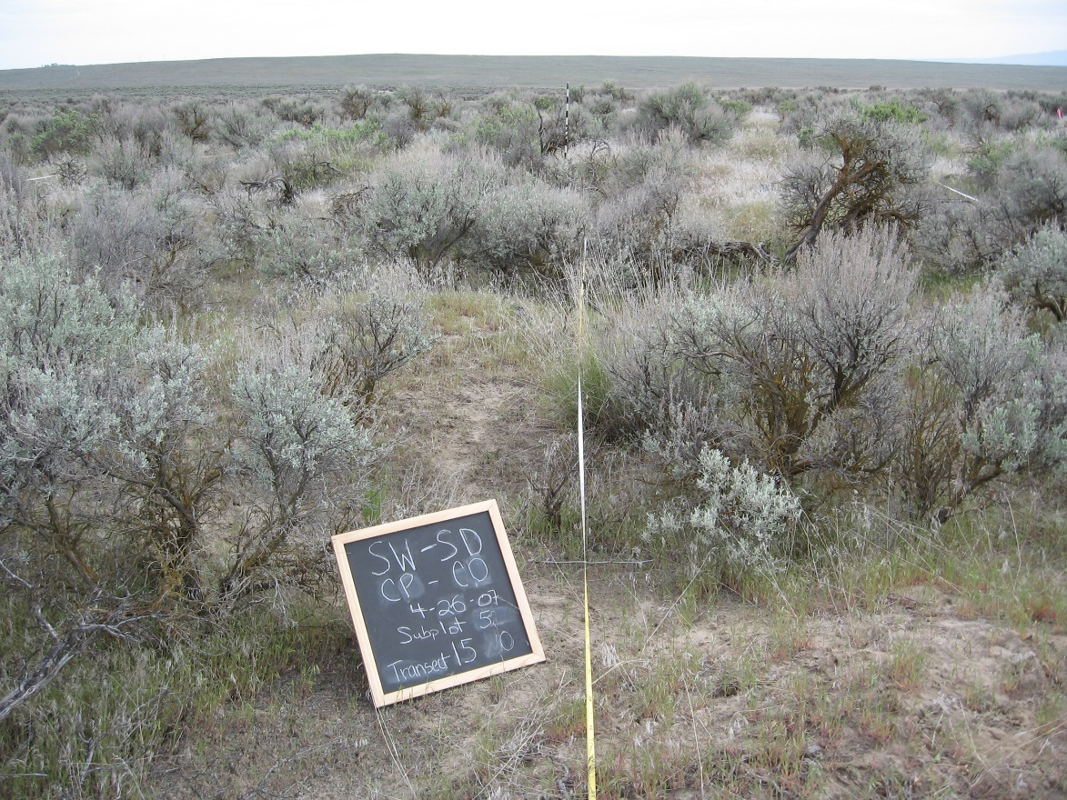**Pre-treatment**

Cover (%)

Shrubs: 26

Perennial Grasses: 6

Annual Grasses: 63

Bare

Ground: 10

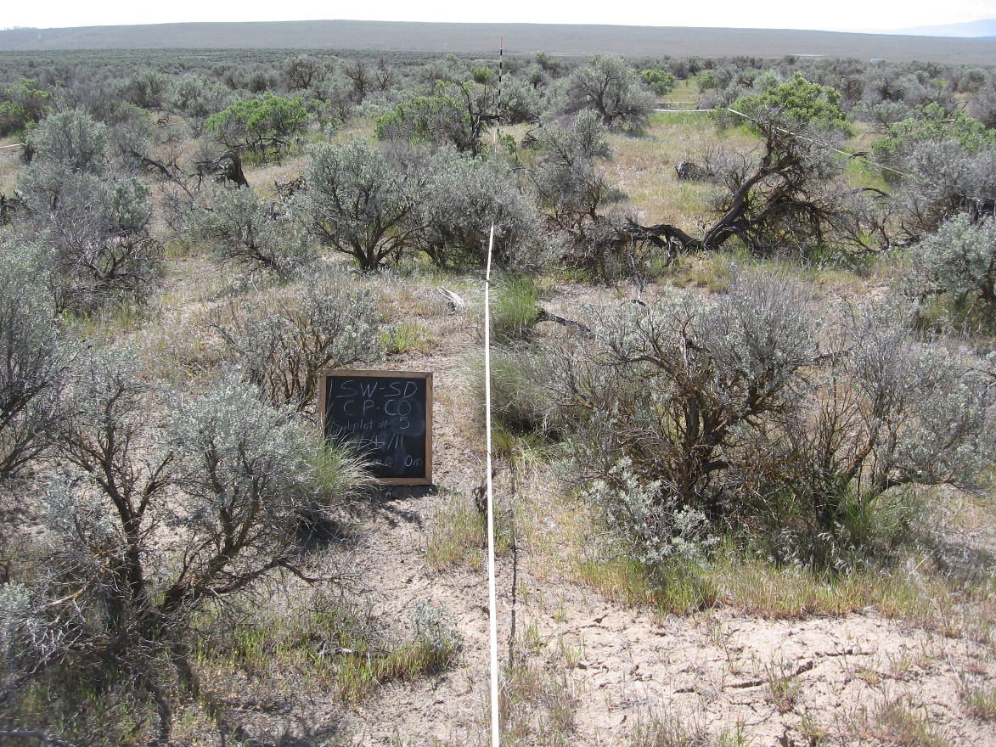

**3 years post**

Cover (%)

Shrubs: 17

Perennial Grasses: 5

Annual Grasses: 39

Bare

Ground: 20

Control

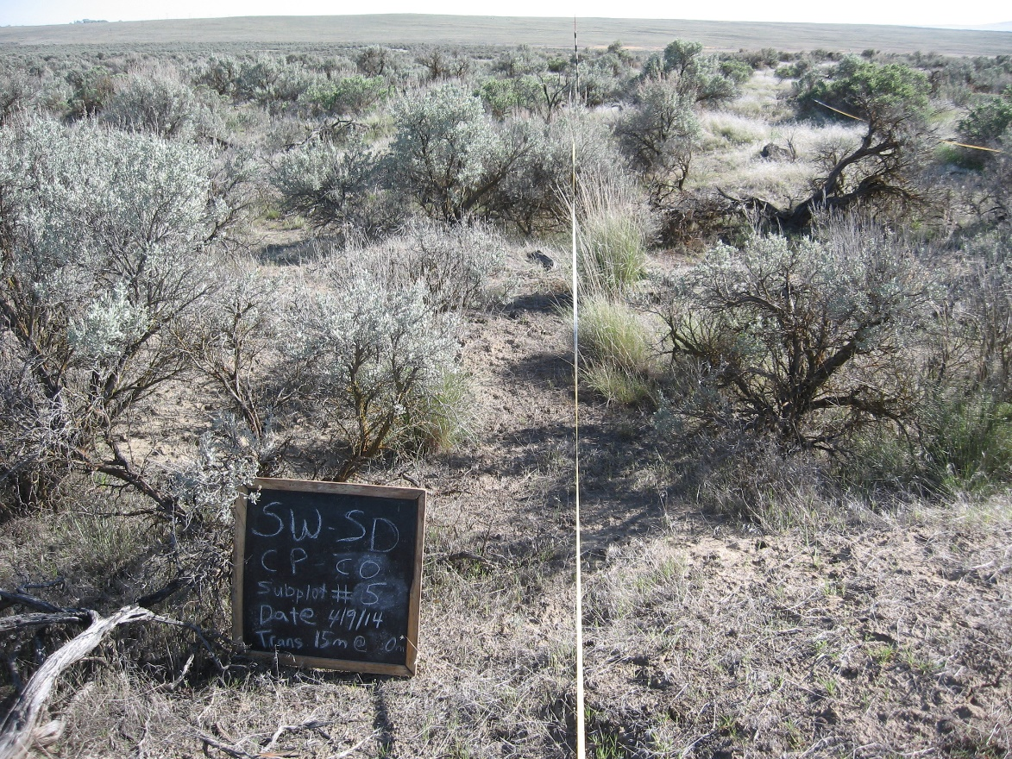**6 years post**

Cover (%)

Shrubs: 19

Perennial Grasses: 8

Annual Grasses: 37

Bare

Ground: 7

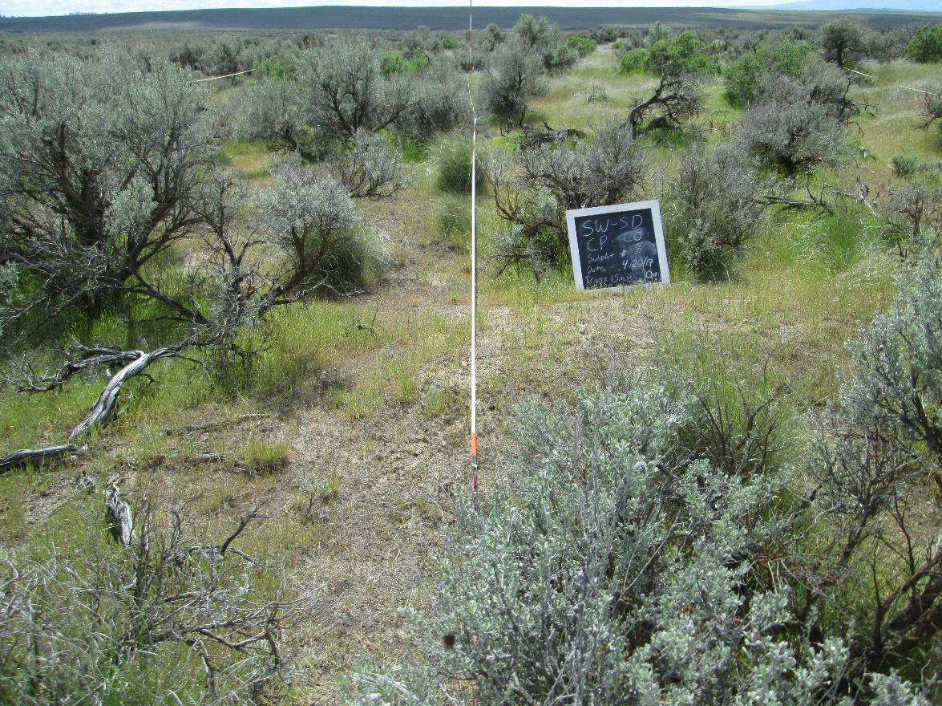

**9 years post**

Cover (%)

Shrubs: 20

Perennial Grasses: 10

Annual Grasses: 61

Bare

Ground: 9

Prescribed Fire

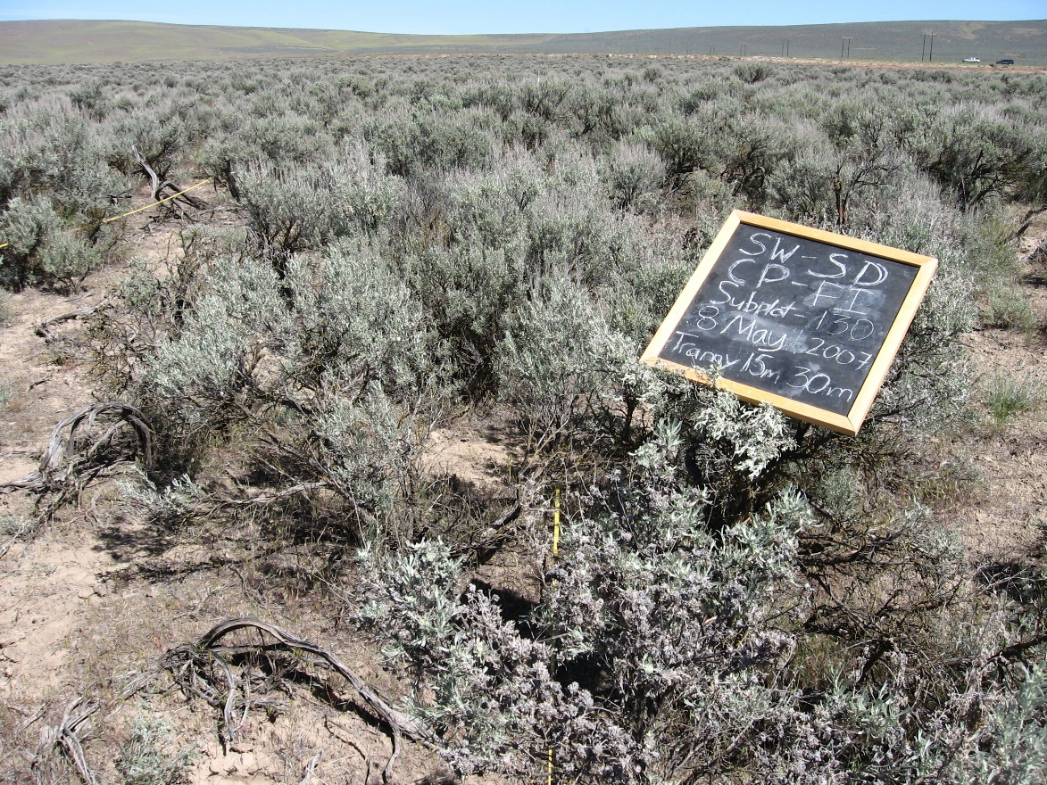**Pre-treatment**

Cover (%)

Shrubs: 36

Perennial Grasses: 7

Annual Grasses: 20

Bare

Ground: 13

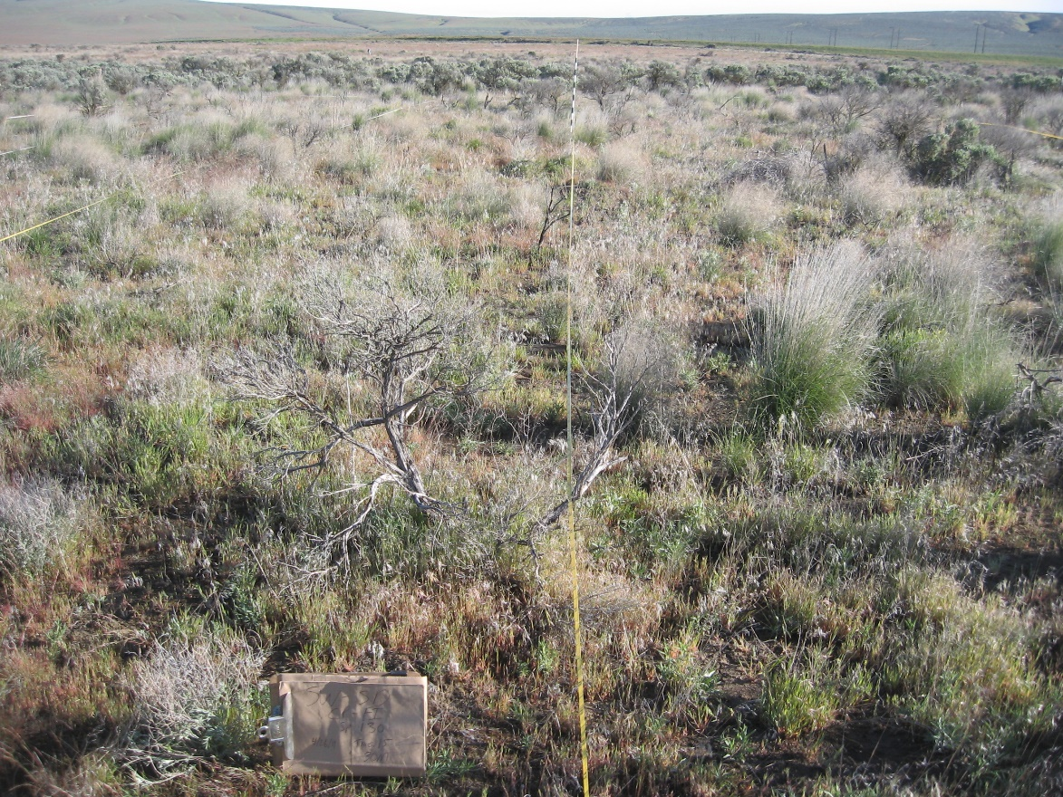**3 years post**

Cover (%)

Shrubs: 0

Perennial Grasses: 15

Annual Grasses: 36

Bare

Ground: 27

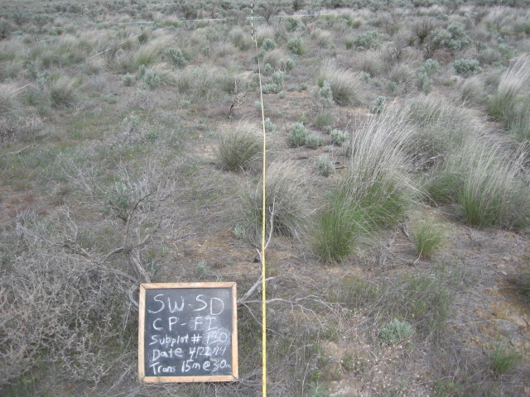Prescribed Fire

**6 years post**

Cover (%)

Shrubs: 5

Perennial Grasses: 27

Annual Grasses: 12

Bare

Ground: 5

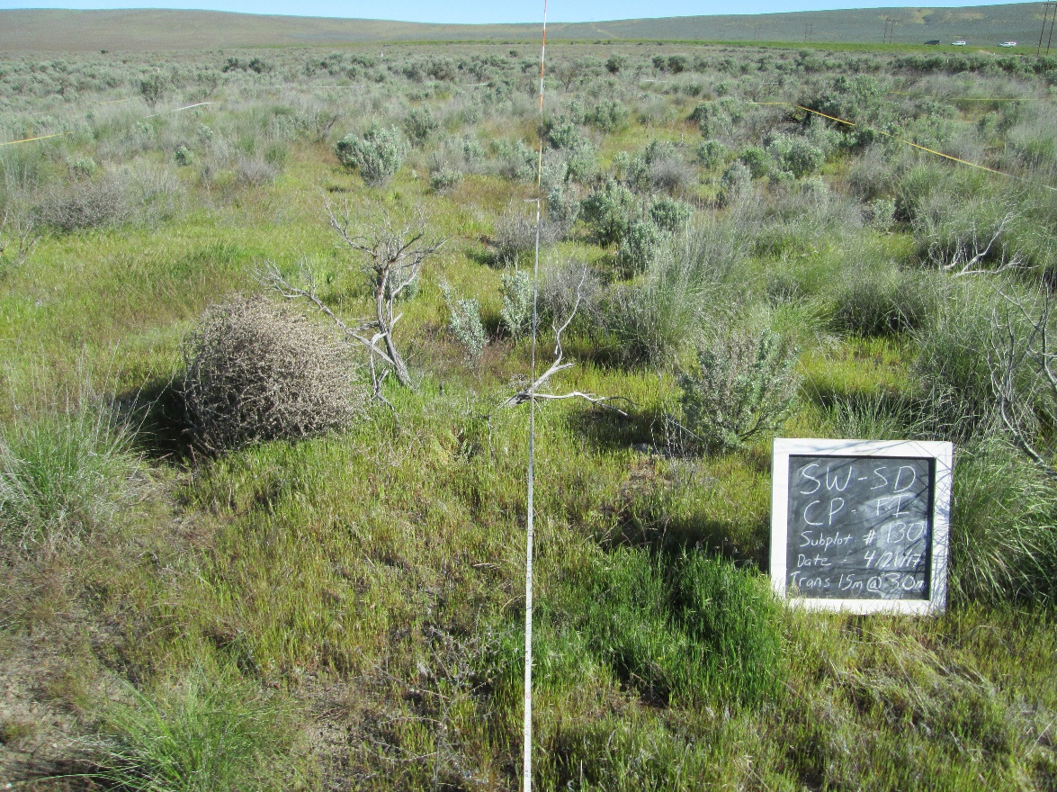**9 years post**

Cover (%)

Shrubs: 7

Perennial Grasses: 41

Annual Grasses: 47

Bare

Ground: 6

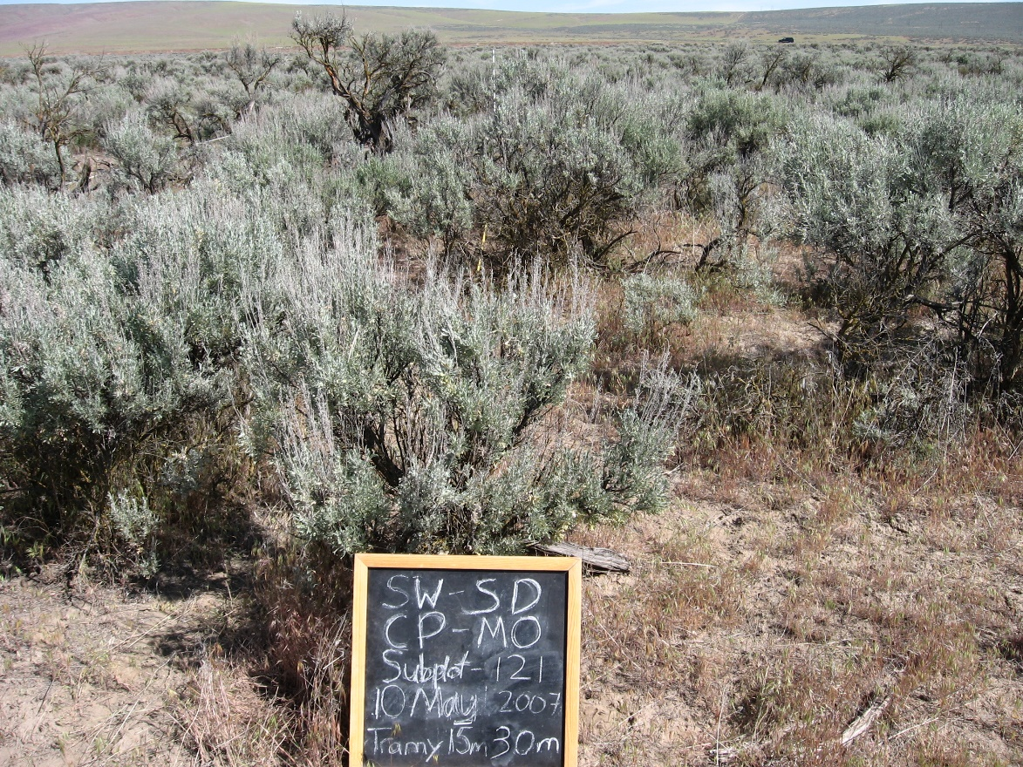Mowing

**Pre-treatment**

Cover (%)

Shrubs: 35

Perennial Grasses: 34

Annual Grasses: 17

Bare

Ground: 15

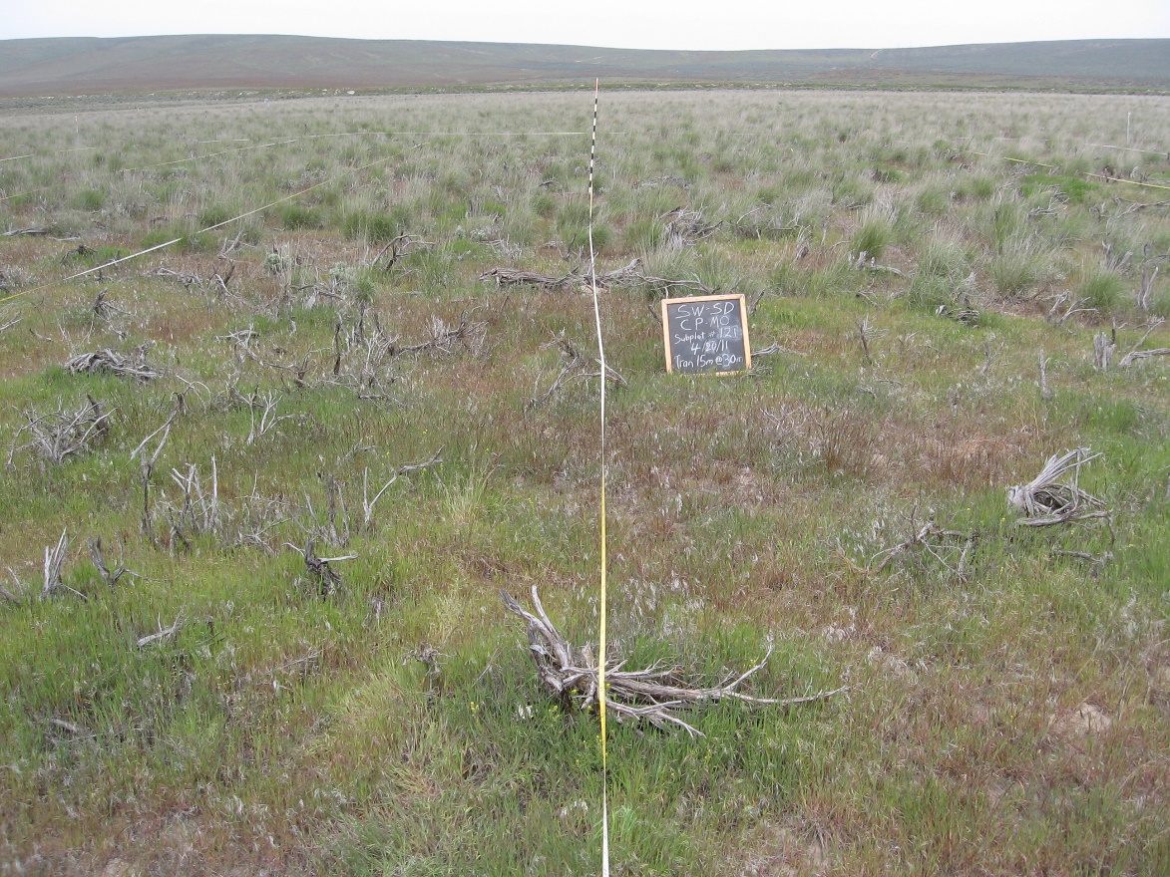

**3 years post**

Cover (%)

Shrubs: 3

Perennial Grasses: 48

Annual Grasses: 25

Bare

Ground: 10

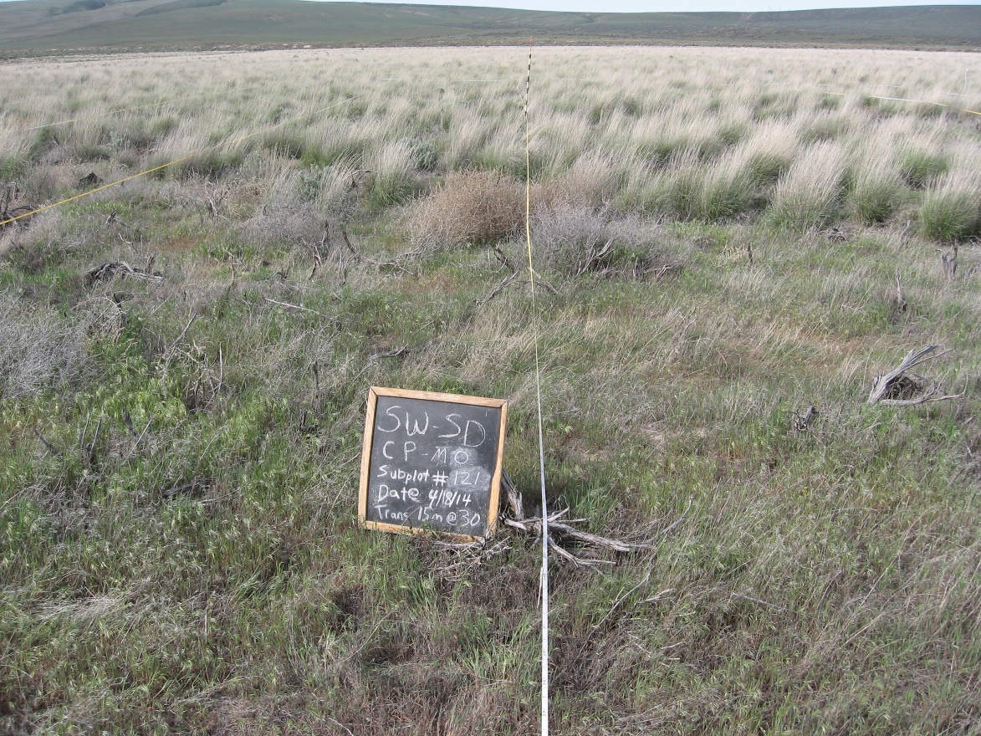Mowing

**6 years post**

Cover (%)

Shrubs: 5

Perennial Grasses: 40

Annual Grasses: 14

Bare

Ground: 7

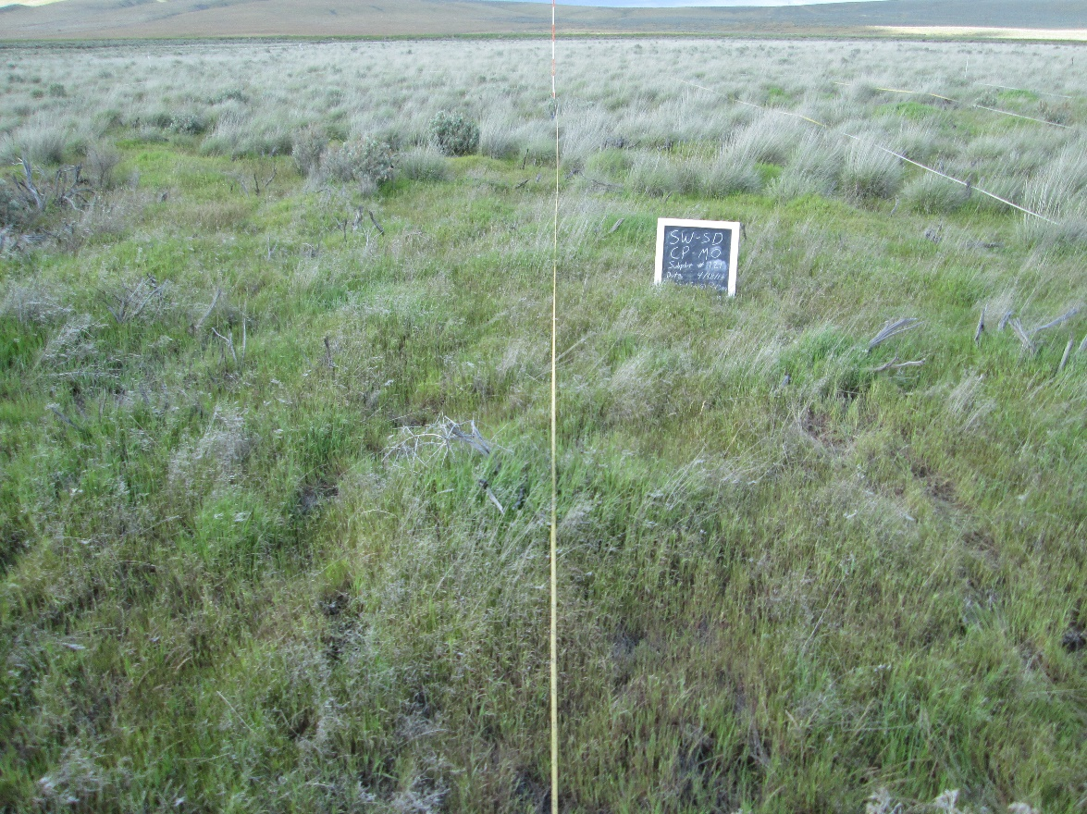

**9 years post**

Cover (%)

Shrubs: 5

Perennial Grasses: 43

Annual Grasses: 57

Bare

Ground: 3

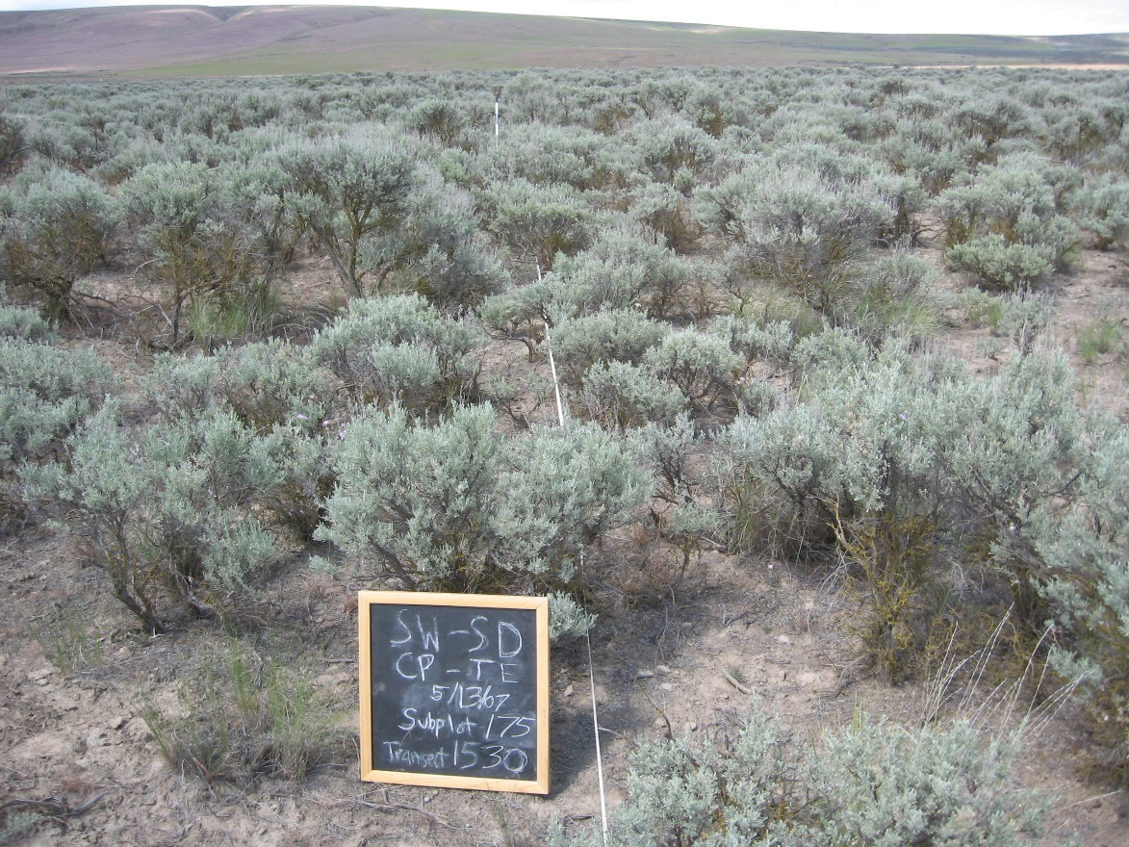Tebuthiuron

**Pre-treatment**

Cover (%)

Shrubs: 25

Perennial Grasses: 27

Annual Grasses: 3

Bare

Ground: 17

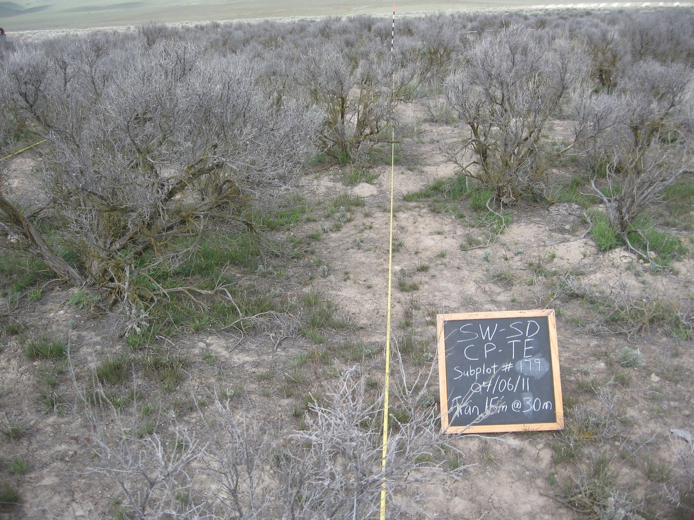

**1 year post**

Cover (%)

Shrubs: 1

Perennial Grasses: 19

Annual Grasses: 1

Bare

Ground: 32

Tebuthiuron

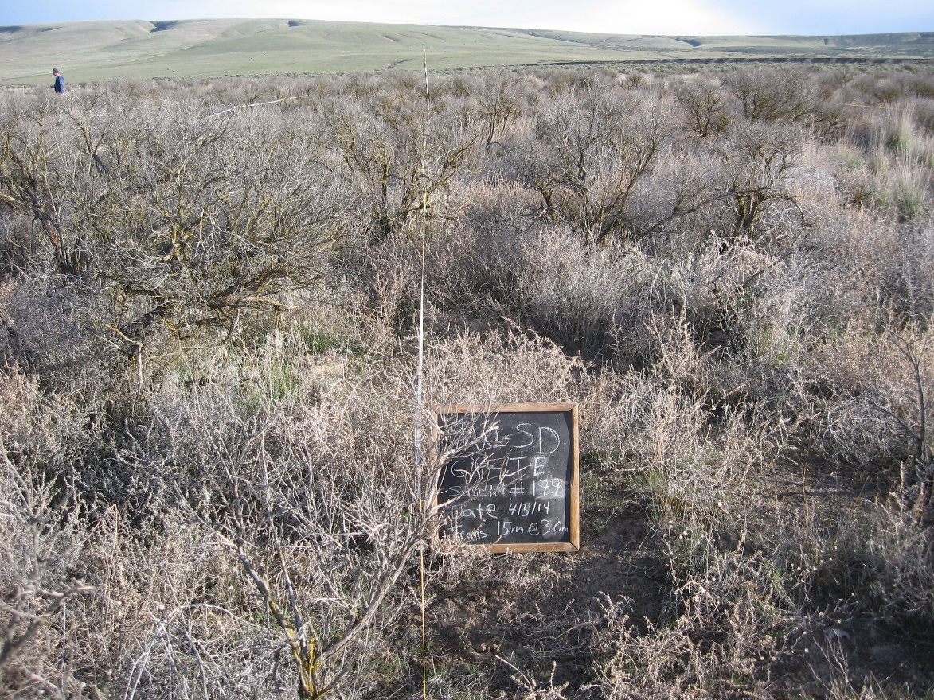**6 years post**

Cover (%)

Shrubs: 0

Perennial Grasses: 13

Annual Grasses: 13

Bare

Ground: 6

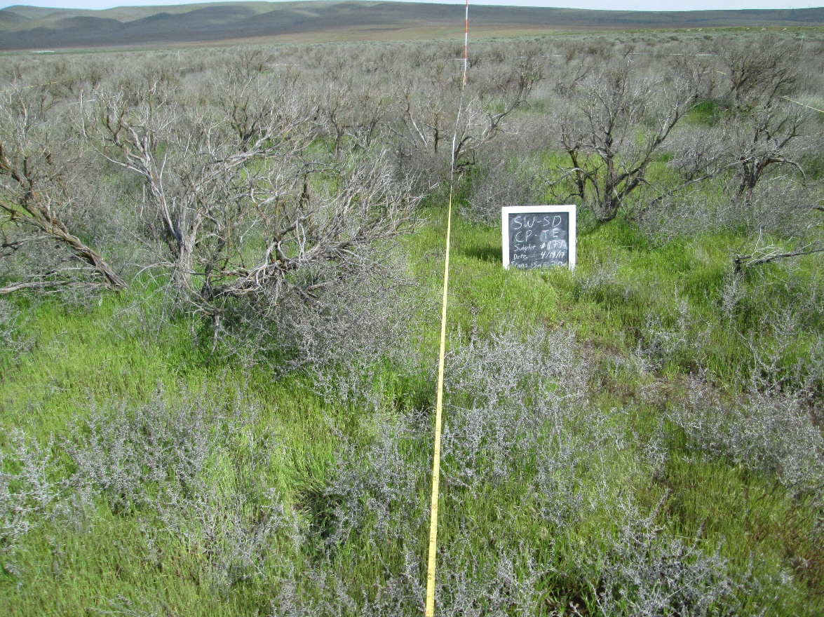**9 years post**

Cover (%)

Shrubs: 0

Perennial Grasses: 17

Annual Grasses: 82

Bare

Ground: 2